**ASSIGNMENT NO 1**

**Computer Engineering Department**



**Machine Learning**

Submitted by

**Safia | 51919**

Submitted to

**Saniya Ashraf**

Lecturer, Department of Software Engineering,

Faculty of ICT, BUITEMS, Quetta.

**TASK NO 1**:

**>> conda info and paste the result.**

**Result**

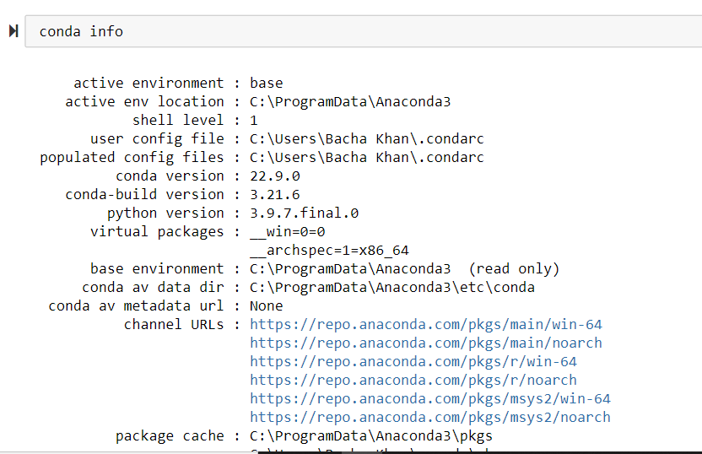

**3.1 Task 2** **Run the following script in IPython and paste the figure created by the script into your report**

**import matplotlib.pyplot as plt**

**plt.plot([1,2,3,4], [1,2,7,14])**

**plt.axis([0, 6, 0, 20])**

**plt.show()**

**Result:**

**import matplotlib.pyplot as plt**

**plt.plot([1,2,5,4],[1,2,5,8])**

**plt.axis([0, 4, 0, 4])**

**plt.show()**

**#51919**

**#SAFIA**

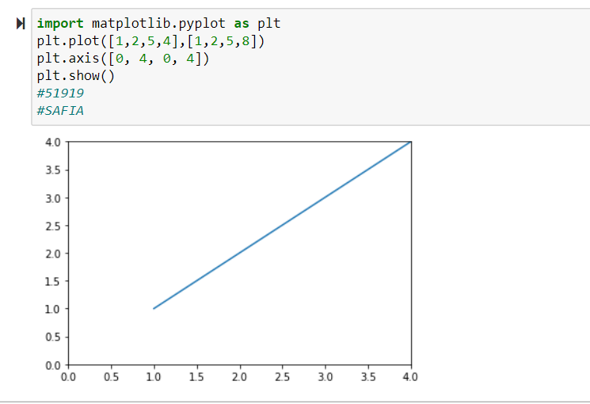

**3.2 Task 3:**

**Use Matplotlib to create a figure of your choice in IPython. Paste your code and figure into your report**

**Result:**

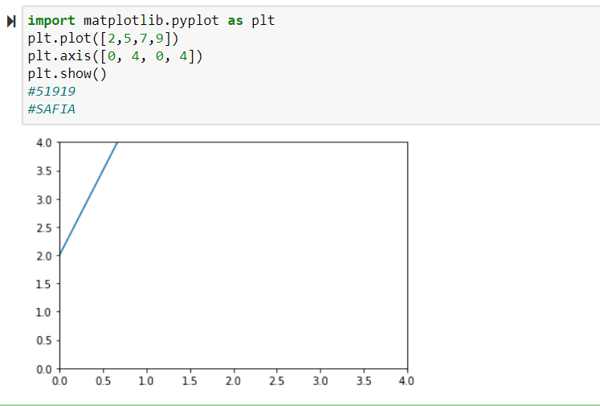

**Task 4**

**Register for a student account here for free private repository access for future projects and go through these tutorials. insert a screenshot of your user page in GitHub in your report.**

**Result**

